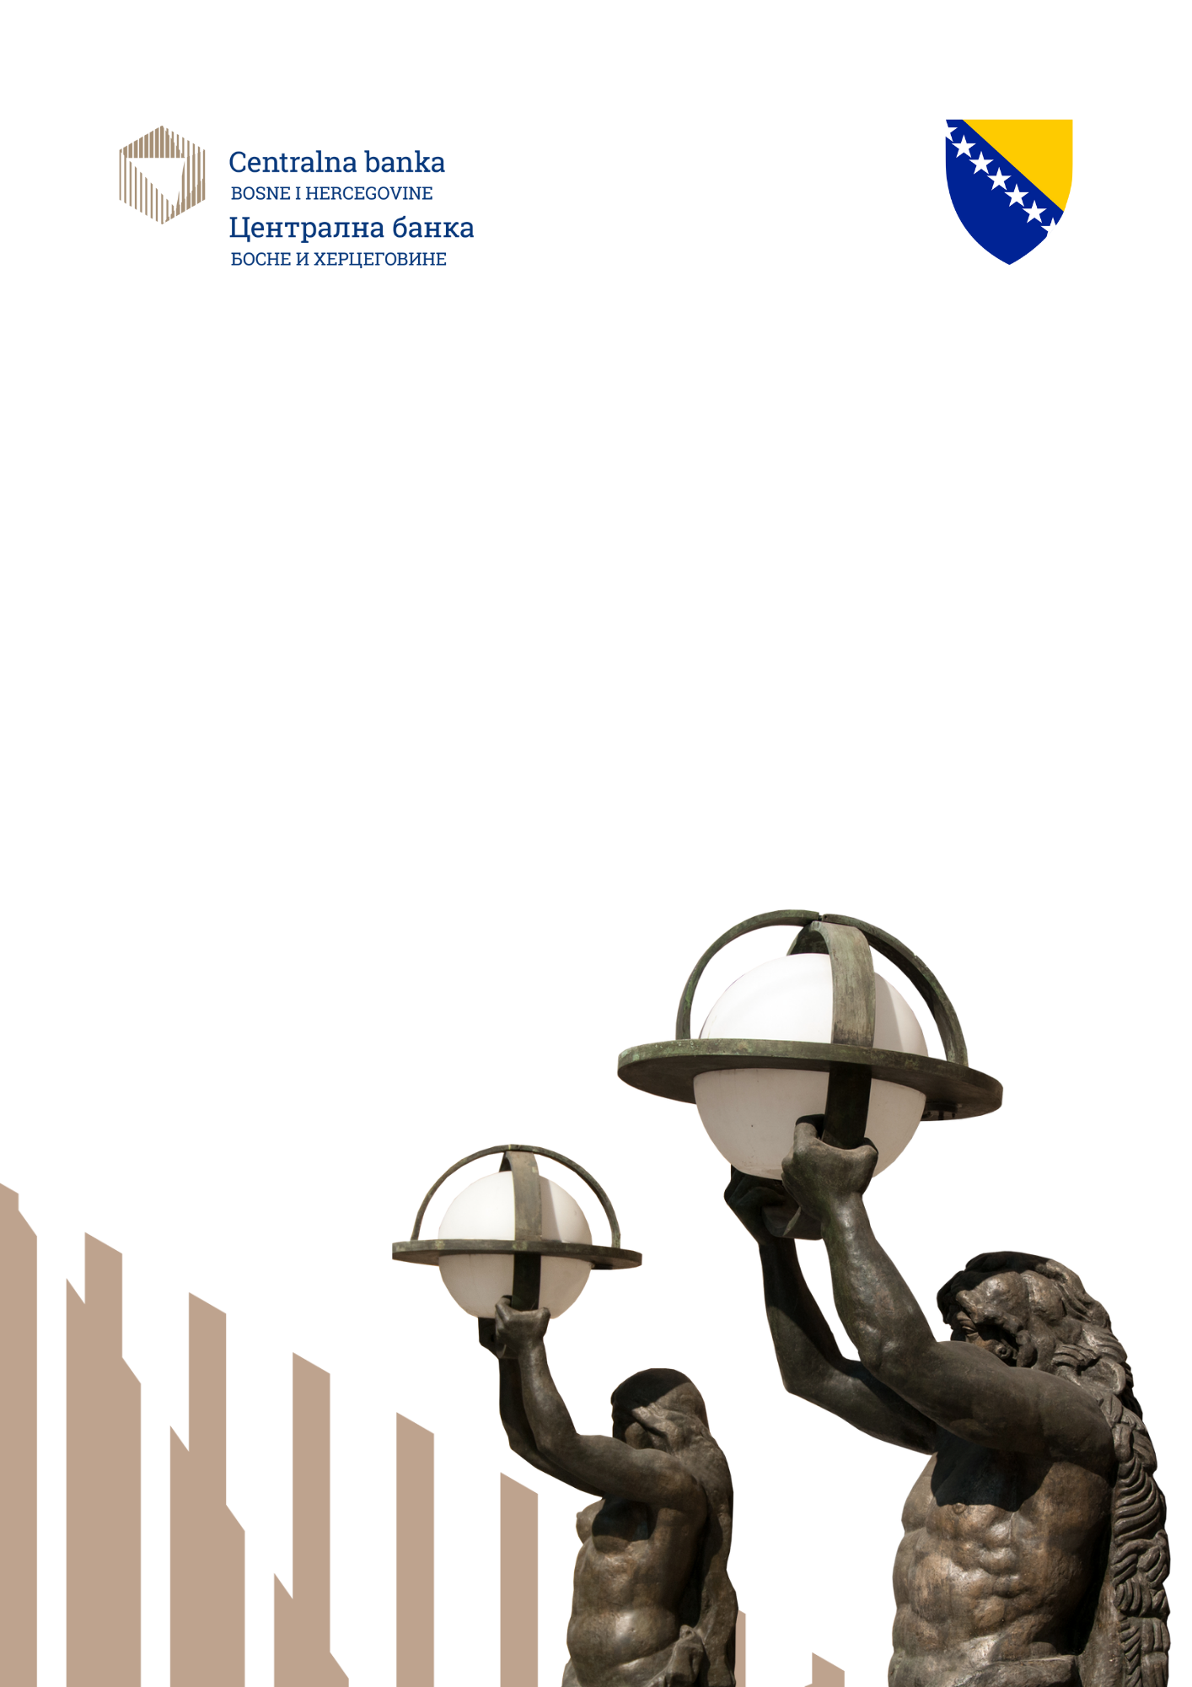
TECHNICAL PROCEDURE on theon verification of the authenticity and suitability of cash
On verification of the cash authenticity and suitability and its returning into
circulation on tverificationhe verification of the authent on the ve

Year 2026

Purpose and aim

The Central Bank of Bosnia and Herzegovina prescribed, in the Decision on the cash verification of the authenticity and suitability (Official Gazette, 25/2026), that banknotes and coins of the convertible mark (KM) may be returned to circulation in machines handled by clients only if their authenticity and suitability have been checked with a type of machine for processing banknotes and coins that has been successfully tested by the Central Bank and if the banknotes and coins are classified as authentic and suitable for circulation.
These technical procedures determine the content, method and criteria of the procedure for checking the operation of machines for the convertible mark processing banknotes and coins in the control of authenticity, suitability for circulation, classification, physical diversification according to the type of machine and recording of transaction data.
The purpose of these technical procedures is to ensure the uniform application of the requirements from the Decision on the verification of the cash authenticity and suitability and its return to circulation (hereinafter the Decision), and that only machines that have been successfully tested by the Central Bank of Bosnia and Herzegovina are put into operation.

Request to check the machine's operations

The Central Bank of Bosnia and Herzegovina conducts a check of the operation of the machine for processing cash based on the applicant's request, submitted on the form from Annex 7 of the Decision, signed by the responsible person and certified with a seal.
The request can be submitted by the machine manufacturer, manufacturer's representative, distributor or obligor, with mandatory submission of the machine's technical characteristics and other data relevant to conducting the test. The request must be submitted in person at the premises of the Central Bank or by email to the address: request.testiranje@cbbh.ba. If the request is submitted scanned via e-mail, the original copy of the request is submitted during machine testing.
The provided data are used exclusively for the purposes of the machine operation check procedure and are treated as confidential data, in accordance with the rules on keeping business secrets arising from the Decision.
Upon receipt of the proper request, the Central Bank determines the date and place of the performance check of the machine and informs the applicant thereof.

Place and conditions of testing

As a rule, the checking of the operation of the machine is carried out at the Central Bank of Bosnia and Herzegovina. If the delivery of the machine is difficult or technically irrational, the Central Bank may decide to perform the performance check at the applicant's location or another suitable location, provided that the applicant ensures all required technical, safety and operational conditions for testing.
The applicant is obliged to make available the machine in a functional state, the necessary documentation, an authorized technical person for support during testing and all other technical assumptions requested by the Central Bank.

- Machine category

Banknote and coin processing machines that can be subject to performance checks are classified into two basic categories:
1. machines operated by customers,
2. machines operated by the employees of an obligor.

For banknotes, customer-handled machines include:
a) banknote payment in machines (CIM),
b) machines for payment/dispensing of banknotes with processing (CRM),
c) banknote payment in and out machines, cash counting machines (CCM),
d) banknote dispenser machines (COM),
e) coin dispenser machines (CDM).

For banknotes, employee-handled machines include:
a) banknote processing machines (BPM),
b) banknote authentication machines (BAM),
c) machines that assist the cashier in processing and depositing banknotes (TARM),
d) machines that assist the cashier in depositing banknotes (TAM).

The general technical requirements that must be met by banknote machines can be found in Annex 3 of the Decision.

For coins, client-handled machines include:
a) coin payment machines that reject suspicious coins (CDM1),
b) coin payment machines that retain suspicious coins (CDM2),
c) coin redistribution machines - which reject suspicious coins (CRM1),
d) coin redistribution machines - which retain suspicious coins (CRM2),
e) coin redistribution machines - which retain suspicious coins and check their authenticity (CRM3).

For coins, employee-handled machines include:
a) coin sorting machines (CSM),
b) coin authentication machines (CCM).

The general technical requirements that must be met by coin machines are found in Annex 6 of the Decision.

5. Classification and sorting

In the process of checking the operation of the machine, the Central Bank checks whether the machine classifies banknotes into the categories prescribed in the Annexes to the Decision, including items that are not recognized as banknotes issued by the Central Bank, suspicious banknotes, banknotes that cannot be determined with certainty to be authentic, authentic and suitable banknotes and authentic and inappropriate banknotes.
For machines used by customers, the rules of classification and handling from Annex 4a apply, and for machines handled by employees, the rules from Annex 4b of the Decision apply.
The check is considered successful only if the machine sorts out the processed cash in a manner that is consistent with the prescribed category and the appropriate handling after classification.

6. Subject of work inspection

Checking the operation of the machine includes checking the method of operation when determining the authenticity of cash, whereby the Central Bank, depending on the type of machine, examines the ability of the machine to determine the authenticity of cash, determine its suitability for circulation, physically sort the checked cash into the appropriate sections, determine the accuracy of the amount of cash and record data about the customer who performed the transaction.
Testing is carried out using a test kit consisting of representative types of known counterfeits and types of suitable and unsuitable convertible mark money.
The procedure for checking the operation of the machine includes:
- checking the ability to recognize authentic banknotes and coins (initial check),
- checking the ability to sort out the counterfeit copies of banknotes and coins,
- checking the ability to determine the quality of banknotes and suitability for circulation,
- checking the ability to monitor transaction data.

7. Verification of the ability to recognize authentic banknotes and coins (initial verification)

The initial check serves to determine the basic ability of the machine to recognize authentic banknotes and coins of the convertible mark in accordance with the technical characteristics of the machine and the requirements of the Decision.
Banknotes and coins are placed in all machine acceptable positions, and the Central Bank evaluates whether the machine correctly recognizes authentic specimens and sorts them into the appropriate categories.
A successfully completed initial check is considered successful if the machine has evaluated at least 90% of inserted banknotes as authentic and suitable for circulation, as this is a prerequisite for continuing the entire procedure of checking the operation of the machine. An additional requirement for machines handled by customers, which must be met, is that the amount of banknotes separated under the suspicion of being counterfeit does not exceed 1% of the total amount of banknotes deposited.

8. Checking the ability to sorting out the counterfeit copies of banknotes and coins

8.1 Checking the ability to sorting out the counterfeit banknotes

The machine's ability to sort out the counterfeit and suspicious banknotes is checked using a representative sample of known types of counterfeits that were known and recorded in the Central Bank of Bosnia and Herzegovina until the date of testing.
Customer-handled machines are checked to ensure that the machine does not accept suspicious or counterfeit banknotes as authentic, to retain or classify them into the appropriate category and, when applicable, to enable tracking of the data on the customer who performed the transaction.
In the case of machines being handled by employees, we check the machine's ability to sort out the suspicious banknotes and all counterfeits from authentic ones and not classify them as banknotes or coins suitable for return to circulation.
The verification of the customer-handled machine is considered successful if the machine does not accept any of the inserted counterfeit banknotes as authentic and if at least 90% of the inserted counterfeits are separated and retained as counterfeited or suspicious banknotes.
Verification of machines handled by employees is considered successful if the machine separates all counterfeited banknotes inserted into the machine.

8.2 Checking the ability to sort out the counterfeited coins

Checking the ability to sort out counterfeited coins and evaluating the results is carried out in the same way as checking the ability to separate counterfeit copies of banknotes.
In addition to the ability to separate counterfeited coins, the ability to separate foreign currency coins that are structurally similar to KM coins is additionally checked, and the machine check in this sense is considered successful if the machine separates all foreign currency coins inserted into the machine.

9. Verification of the ability to define the quality of banknotes suitable for circulation

The suitability check includes the assessment of the machine's ability to determine whether authentic banknotes and coins are suitable or unsuitable for circulation, in accordance with the minimum standards and criteria prescribed by the Decision and its Annexes.
For banknotes, the minimum standards for automatic suitability verification from Annex 1 of the Decision are applied.
Checking the ability of the machine to determine the quality of banknotes according to suitability for circulation is carried out using a certain number of authentic banknotes suitable for circulation and a number of authentic banknotes unsuitable for circulation (worn and damaged banknotes).
Worn KM banknotes are banknotes that have worn out due to use, and the quality of the paper and colours have significantly decreased, i.e. they are not suitable for circulation due to their appearance.

Damaged banknotes KM means banknotes that are:
a) split at edges or torn into two or more parts, so their parts are assembled by gluing or can be assembled into whole banknotes,
b) banknotes missing one or more parts due to damage and
c) banknotes that have been damaged by grease, paint, etc., or have been burned at spots, burnt through paper, corroded or faded.

Banknotes are inserted into the machine in all positions that the machine accepts according to the technical characteristics of the manufacturer. The machine's check is considered successful if the machine has evaluated a maximum of 5% of the total number of inserted authentic banknotes (worn and damaged) unsuitable for circulation, as authentic and suitable for circulation.

10. Monitoring of transactions

For customer-handled machines, the ability of the machine to record and store information about the customer who performed the transaction is also checked when the machine retains banknotes classified as suspicious or as unauthenticated banknotes.
The monitoring of transactions is considered satisfactory if there is a reliable link between the retained banknotes and data on the account holder or other identification data that enables unambiguous identification of the depositor, in accordance with the requirements from the Decision and rules that are equivalent in content to the access in the technical procedures of the Central Bank.

11. Results of the operations check

After the check has been completed, the Central Bank prepares a Report on the successful check of the operations of the machine and delivers it to the applicant within 15 days from the day of the check of the machine operations.
The report is valid for one year from the date of issue.
Only machines that successfully pass the operation check can be included in the List on successfully tested machines that the Central Bank determines and publishes on its website.

12. Recheck

No later than one month before the validity of the Report expires, the applicant is obliged to submit a request for the issuance of a new Report on the successful check of the machine operations.
Rechecking the operations of the machine is also mandatory after each upgrade or update of the hardware and/or software of the machine, in case of the appearance of a new type of cash counterfeiting, as well as when the Central Bank releases a new issue of banknotes and/or coins.
If the machine does not meet the criteria during the recheck, it cannot remain on the List on successfully tested machines.

13. List of successfully tested machines

The list of successfully tested machines contains information about the type of machine, the name of the manufacturer or representative, the name of the machine, the designation of the hardware and software version, the denominations of cash that the machine can process and the date of publication on the List.
For machines that have the same hardware, software and other components as machines already included in the List, the Central Bank may, in accordance with the Decision, accept a Declaration of Conformity instead of full testing again, for inclusion in the List.

14. Final provisions

These Technical procedures apply to procedures for checking the operations of machines for processing banknotes and coins, which are carried out on the basis of the Decision on the verification of the authenticity and suitability of cash and its returning to circulation.
For issues that are not regulated in detail by these Technical procedures, the provisions of the aforementioned Decision and its appendices are directly applied.

